How to Use Mackin VIA e-books

1. Visit the Mackin VIA site. You can access it via the Library Media Center website (knoxschools.org/cartereslmc) or use the following link: <https://knoxschools.mackinvia.com/Enter/NoAuto>

The link will take you to a page that looks like this:

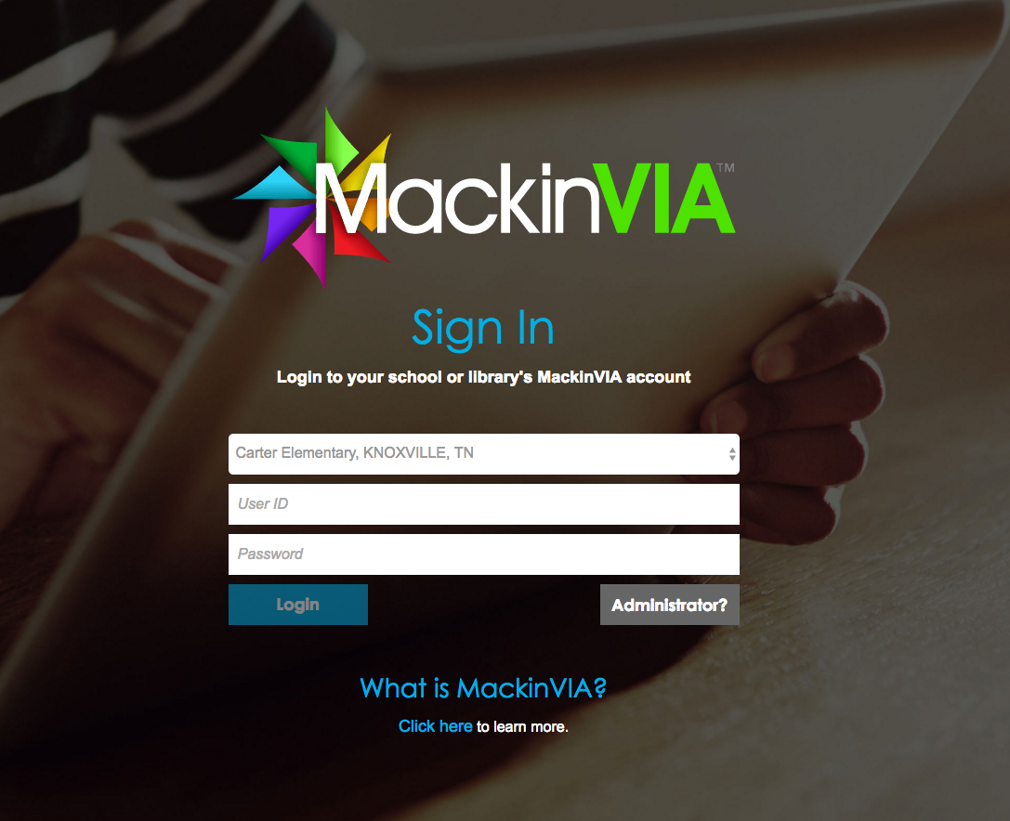

2. Make sure Carter Elementary is selected in the first drop down menu.

3. Type in your active directory username and password in the boxes for username and password.

For students the user name will be a capital S and their student ID. (Exp. S1234567)

Their password will be the student’s first and last initial (official name no nicknames) in CAPS, the last 4 digits of their student idea, and kcs (Exp. for Sonya Cameron it would be SC1234kcs)

4. Once you put in your information, you will see a screen like this:

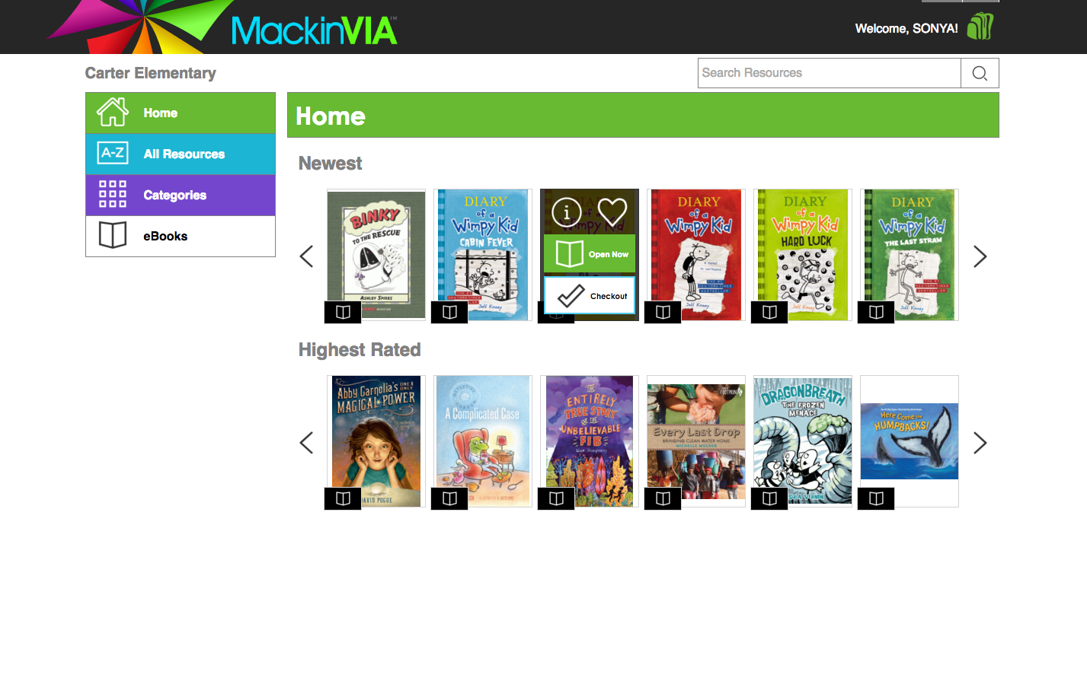

5. Use the side bar to find books by category or to browse all eBooks.



6. After choosing a way to browse for books, you will see a screen like this:

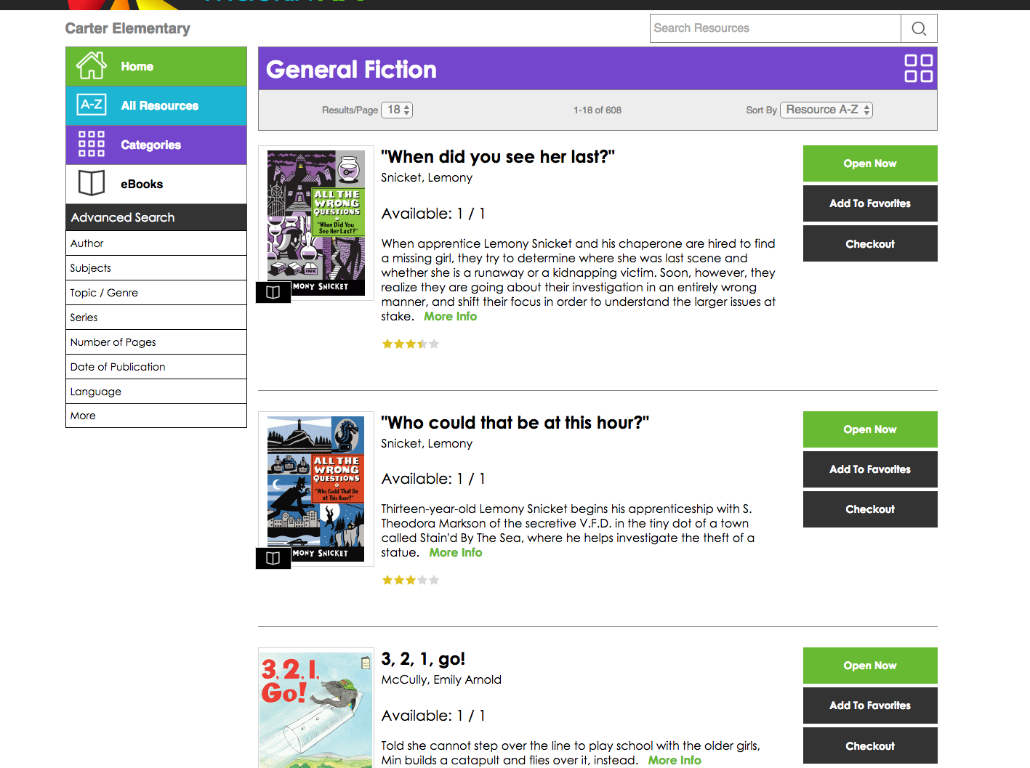

7. Click on “open now” to read the book, or click “checkout” to have access to it for 6 days.



8. To access your book while it is checked out, visit the Mackin VIA site (direction 1) and click on the green backpack in the top right corner.

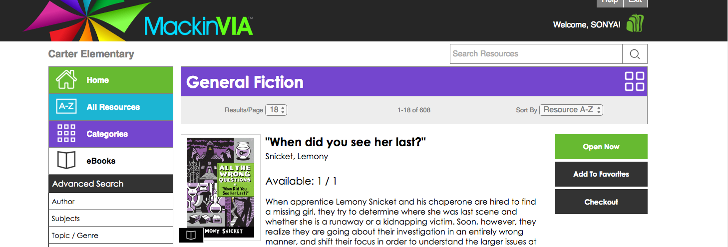

9. Click on checkouts from the backpack menu.

